Derivatives

Definition and Explanation of Derivative
A derivative represents the rate at which a function is changing at any given point. It is a fundamental concept in calculus and provides a measure of how a function's output changes as its input changes.

Formal Definition
Given a function f(x), the derivative of f with respect to x is defined as:
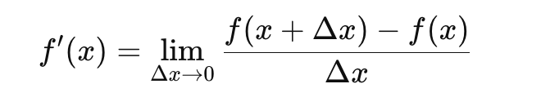
This definition can be interpreted as the slope of the tangent line to the function graph at point x.

Relevancy to Machine Learning
Derivatives are crucial in machine learning, particularly in the optimization of models. They are used in algorithms such as gradient descent, which iteratively adjusts model parameters to minimize a cost function. Key applications include:
- Gradient Descent: An optimization algorithm used to minimize the cost function in machine learning models. It relies on derivatives to update the parameters.
- Backpropagation: In neural networks, backpropagation uses derivatives to calculate gradients, which are then used to update the weights of the network.
- Regularization: Techniques like L1 and L2 regularization involve derivatives in their optimization processes to prevent overfitting.
- Hyperparameter Tuning: Derivatives help in understanding how changes in hyperparameters affect the performance of the model.
- Sensitivity Analysis: Derivatives are used to measure how sensitive the output of a model is to changes in input variables.

Derivative Rules
Understanding the basic rules for finding derivatives is essential for solving problems in calculus and applying derivatives in machine learning. Here is a complete set of common derivative rules:

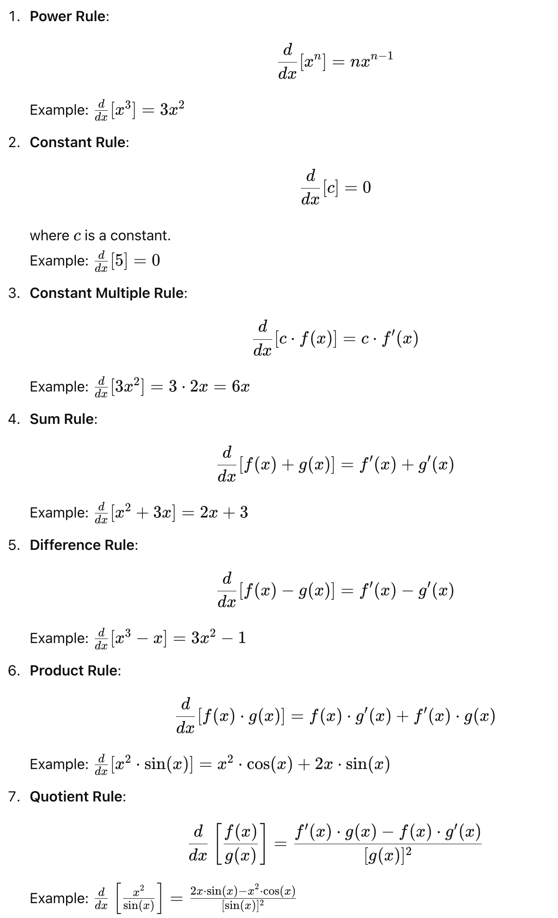
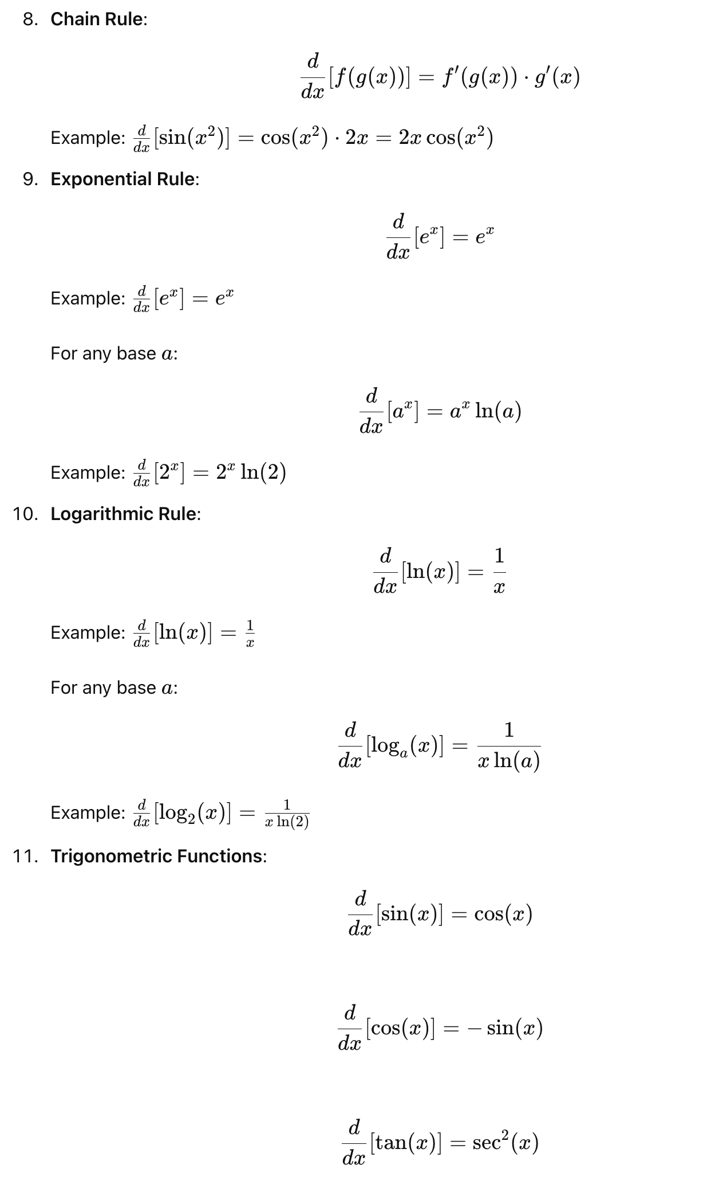
Worked out Examples

The concept of derivatives is essential in machine learning for optimizing models and understanding how changes in input affect output. Derivatives provide the mathematical foundation for algorithms like gradient descent and backpropagation, enabling effective model training and fine-tuning. Understanding the basic rules of differentiation is crucial for solving these problems.
